IT Project

Final Draft

“Predictive Maintenance for Industrial Machinery”

By

Venkata Varun Sai Nallapaneni

# Abstract

The topic sentence is concerned with building an early warning system for industrial equipment based on the usage of machine learning methods. This study has a purpose of using data analysis to be proactive in identifying imminent machine breakdowns and thus create the need for minimum downtime and repair costs compared to the reactive or preventive approach. The methodology that is selected is the Waterfall approach along with the phases included, like requirements gathering, specifications designing, implementation, testing, deployment, and maintenance. Collecting field data through sensors and developing predictive models are also part of the research methodology. Additionally the conceptualization in the paper shows various constrains such as cost efficiency, compiled data sources, implementation problems and other security issues. The top outcome of the study is that it presents a progression of upgrading the maintenance strategies to automated data-driven one which is based on advancement of sensor technology, data analysis, and machine learning. The benefits gained from predictive maintenance include reducing unsolicited downtime, planning maintenance more optimally, lengthening asset lifespans and improving the reliability, respectively. The result of this research alludes to what might be required to truly achieve optimal predictive maintenance systems by taking advantage of ongoing technology developments and rethinking of industrial processes. There are responsibilities and Moral questions around data privacy and safety that are addressed as well as issues that could potentially emerge and solutions that can be introduced such as system integrations, model Scalability, and management of resources. This research goes beyond the field as it takes care of some gaps in previous studies, including assessing the machine learning models in all vehicles, getting the condition-based maintenance planning, and improving the scalability and cross-sector applicability.

Keywords: Predictive maintenance, industrial machinery, machine learning techniques, data analysis, downtime, maintenance costs, Waterfall approach, sensor technologies, data analytics, reliability, performance, ethical concerns, scalability.

Contents

Abstract 2

1. Introduction 7

1.1 Background and context 7

1.2 Problem Statement 7

1.3 Research Questions 8

1.4 Significance and motivation 9

1.5 Literature review and Gaps in Literature 9

1.6 Methodology and approach 10

1.7 Structure of the paper 11

2. Literature Review 14

2.1 Introduction to the topic 14

2.2 Historical context 14

2.3 Methodologies and approaches: 15

2.4 Key concepts 17

2.5 Empirical studies and findings: 17

Case study 1: Predictive Maintenance of Industrial Machines using Machine Learning 17

Case study 2: Machine learning based predictive maintenance of motor using single model analysis 21

Case study 3: Predictive Maintenance and Monitoring of Industrial Machine using Machine Learning 24

2.6 Research trends and developments 27

2.7 Conclusion and research rationale: 28

3. Methodology 30

3.1 Research design 31

3.2 Application development approach 32

3.3 Requirements analysis 33

3.4 Design phase 33

3.5 Development 33

3.6 Testing and quality assurance 34

3.7 Data collection 34

3.8 Iterations and Updates 34

3.9 Evaluation metrics 34

3.10 Ethical considerations 34

3.11 Limitations 34

3.12 Conclusion of methodology 35

4. Results and Discussion 36

4.1 Results 36

4.1.1 Implementation 37

4.2 Discussion 42

5. Conclusions, Recommendations, and Future Works 43

References 45

List of Figures

Figure 1: System Architecture. 19

Figure 2: Flow chart. 19

Figure 3: Data Flow diagram. 19

Figure 4: Flow diagram. 22

Figure 5: Block Diagram of Data Fetching Mechanism. 25

Figure 6:Master-Slave Serially Connection Used In ModBus Protocol. 25

Figure 7:Use case diagram. 32

Figure 8:DFD diagram 33

Figure 9: Entity-Relationship (ER) Diagram. 34

Figure 10: app.py 37

Figure 11: index.html 38

Figure 12: Sensor reading over Time 39

Figure 13: Oil level vs Pressure 40

Figure 14: Humidity vs Temperature 40

# 1. Introduction

## 1.1 Background and context

When it comes to equipment maintenance in industrial machinery, unanticipated equipment breakages coupled with increased machine downtime have been a significant worry for organizations as far back as time immemorial. Classical types of maintenance are efficient, but they inevitably lead to misallocation of resources and high operating costs. Preventive maintenance usually utilizes fixed schedules or threshold-based methods, which may cause both avoidable maintenance and critical items to be left out. With industries going to deploy those sensor-integrated devices more, there is an ample chance to apply machine learning techniques for predictive maintenance (Swarangi, Aniket, & Shivani, Predictive Maintenance of Industrial Machines using Machine Learning, 2021). Machine learning models provide us with an opportunity to use sensor data for the detection of impending equipment breakdowns before it happens and so to avoid prolonged downtime and expensive maintenance. Although the implementation of such predictive maintenance systems entails the use of powerful techniques and practices, the establishment of these systems is challenging. The modern computer science study examines the weaknesses of current machine learning models to analyze sensor data for forecasting maintenance, adaptability in various engineering systems, and complexities of real-world implementations.

## 1.2 Problem Statement

Challenges caused by unplanned equipment and associated downtime in industrial equipment can significantly affect operational efficiency and result in high maintenance costs. Preventive maintenance strategies on the edge are often based on fixed schedules or early threshold-based processes, and unnecessary maintenance or critical issues are overlooked. As industries increasingly adopt devices with sensors, there are opportunities to harness the potential of machine learning for future refinement. The main problem addressed by this research project is the need for robust methodologies and best practices for implementing prepared forecasting systems for mechanical devices. In particular, the project aims to explore the limitations of current machine-learning models in analysing sensor data for predictive maintenance. Explore the adaptability of machine learning algorithms to different engineering systems and devices.

Examine the practical challenges of implementing a predictive maintenance system in real industrial situations. Analysis of factors that contribute to the effectiveness and reliability of a predictive maintenance system. Develop best practices based on practical experiences to improve implementation efficiency and ensure cost-effectiveness. Analysis of the cost-effectiveness of implementing predictive maintenance compared to traditional preventive or reactive maintenance. Identify strategies for improving efficiency and reducing costs while maintaining predictive maintenance system reliability. An evaluation of the long-term economic benefits and return on investment associated with successfully implementing a predictive maintenance program. The study aims to provide valuable insights and guidance to organizations implementing predictive maintenance engineering devices. The results of this study will not only enhance maintenance prediction but also offer practical recommendations for the successful integration of machine learning models in industrial environments.

## 1.3 Research Questions

1. What strategies can the machine learning adapt to make sensor data analysis so accurate in predictive maintenance on industrial machinery?
2. How can we make the best practices based on practical experience toward effective and cost-effective implementation of a reliable predictive maintenance system in industrial settings?

## 1.4 Significance and motivation

This project aims to create a mechanism that will provide new types of maintenance approaches in industrial sites. In the light of a predictive maintenance system for industrial machinery, this research seeks to overcome the shortcomings of traditional maintenance approaches, thus paving the way for more proactive and cheaper maintenance strategies. The study indicates that the project's outcomes are significant in operation, maintenance, and safety. Additionally, it has an essential value for the predictive maintenance and machine learning knowledge base (Patil, Jadhav, Bardiya, Davande, & Raverkar, 2023). By studying ways to foster higher precision and adaptability in sensor data analysis and identifying the usability problems and the most suitable practices for practical implementations, the project contributes hugely to both researchers and practitioners. One can expect meaningful outcomes from this study, which include theoretical developments in predictive maintenance methodologies and practical applications of machine learning algorithms in industrial environments.

## 1.5 Literature review and Gaps in Literature

Research on predictive maintenance for industrial machinery has looked into the applications of machine learning models to process sensor data and predict machine failures. One of the studies examined different machine learning approaches, including random forests, decision trees, Naive Bayes, and CART (Karrupusamy, Machine Learning Approach to Predictive Maintenance in Manufacturing Industry - A Comparative Study, 2020). These machine learning approaches demonstrated their potential strength and identified their drawback in handling complicated data patterns. Different issues in data interpretation, such as distinguishing between standard deviations and actual faults, as well as data transmission security pitfalls that connect to the cloud platforms, are found. The issue of data quality has been addressed, and one of the ways that has been stressed to support the predictive maintenance models is through preprocessing, which includes examining, cleaning, and transformation.

Further, there needs to be more research on the possibility of using models for different machinery in different industries. Implementing the planning for maintenance, resource allocations, and condition-based maintenance have been topics of discussion. However, the development of such evaluation metrics and performance assessments on unseen data is still relevant. Scalability, especially over how to handle large volumes of data efficiently, is also a critical aspect yet to be fully explored. This project intends to bridge the abovementioned gaps by developing a predictive maintenance system that considers cost-effectiveness, data quality, security, scale-up, and cross-sector scalability.

## 1.6 Methodology and approach

The project will stick to the Waterfall methodology for development, which is quite structured because the project specifications are clearly understood and stay the same. This approach uses the main principle of proceeding through the phases in sequence with the completion of the phase before moving to the next one. The comprehensive requirement-gathering process will occur where project scope, objectives, functions, and constraints will be implemented. Later, system design will be carried out where specifications like web application architecture, components, database design, user interface, and system interfaces should be created. The design will be done next, and the implementation will start after. This will involve the coding of web applications, the development of machine learning models, the integration of sensors, and the setting up of data pipelines for the collection and processing of sensor data.

After implementation, testing rigor will occur to handle unit, integration, and system testing to find and fix any defects or problems. The deployment of the tested software will follow, with setting up servers, configuring databases, and putting both the web application and the machine learning models into operation in a production environment. Post-deployment, ongoing maintenance, and support will be provided via system health monitoring, implementing user feedback, development of update mechanisms, and improvement/embellishment. Throughout the process, documentation will be kept at a detailed level for tracking progress, knowing its dependence on the project objectives, giving an explicit mapping for successful project implementation, and assisting in good project management to successfully deliver the predictive system for industrial machinery.

## 1.7 Structure of the paper

The report is formulated to give the readers a general idea of the research strategy presented. It delineates the different sections. It is organized as follows: It is organized as follows:

Introduction: Introduces the subject, explains its weight, and gives the reason for its implementation.

Literature Review: Surveyed previous research in predictive maintenance and machine learning, pointing to the primary studies and conclusions.

Methodology: Describes how the predictive maintenance system was built, such as capturing the data, selecting the model, and evaluating parameters.

Results: Presents the results of the research, which include assessment of machine learning model accuracy, issues to be dealt with in practice, and good practices.

Discussion: Examine the consequences of the experimental outcomes and how they affect industrial maintenance processes.

Conclusion: Summarize the study's primary outcomes and develop ideas for future work.

References: Spell out the resources quoted at intervals within the report.

Through the use of this structure, readers can track the report and hence grasp all the facts clearly and concisely.

In summary, this research paper aims to analyze the existing situation and establish the solid action plan on how to use the most efficient mean for predictive maintenance for industrial devices. The paper began with a setting of the scene of equipment maintenance nuances and the disruptive effect of machine learning technology on the maintenance function. Through this, what surfaced was that not only the results were important to making the processes both highly effective and cost-efficient but also passed by an enormous value for the maintenance of the predicted machines as well the machine learning advancement. The element of review of literature revealed that the existing research gaps exists, in the application of machine learning models across the whole range of industrial sector and the scalability of predictive maintenance systems. With the Waterfall approach the structure adhered to which is a systematic and cohesive way the project to success. The outcome is achieving predictive maintenance system including requirements gathering to maintenance after launching. Through the completing of these goals the research plan will not only hopefully drive new theoretical developments in the predictive maintenance but also useful practical part to take it into practice for seamless industrial applications. The planned sheet format of the methodology section presented here aims to guide readers to the research results in a structured fashion. The later sections of results and discussion will further examine the accuracy of the machine learning models, encountered practical challenges, and give best practices to be followed. Last but not least, the summary presents the major outcomes for the study and gives rises to the direction for the future study. Herein, the thrust of research is aimed at complementing existing predictive maintenance frameworks so as to enable organizations to fully exploit the potential benefits offered by emerging advancements of machine learning. Through enhancing the accuracy, adaptability, and cost effectiveness of predictive maintenance systems, this study seeks to effectuate industrial maintenance practices to a proactive and efficient classier era which serves to heighten operational efficiency, lessen time as machine down period, and savage cost for industrial corporations in the industry.

# 2. Literature Review

## 2.1 Introduction to the topic

The present research approach is "Predictive Maintenance for Industrial Machinery," the main practical area within modern industrial activities. As industry equipment gets more complex and shutdown/maintenance times come with substantial financial implications, predictive maintenance has become a key strategy to minimize risks and enhance operational efficiency (Chaitali, Sanika, Asmeeta, Ankita, & Mahee, 2023). Predictive maintenance systems leverage machine learning models for sensor data analysis to proactively detect faults in the equipment before they occur, thus avoiding costly breakdowns and repairs. In the large picture of industrial engineering and maintenance management, the predictive one stands out as the new way of thinking compared to the traditional reactive or preventive approaches. The essence of PM is PPD (preventive-proactive-demand/planned-scheduled). Hence, it enhances overall productivity and profitability through reduced downtime and optimizing maintenance schedules. The industries that pursue digitalization and automation in-depth must take on board new predictive maintenance technologies to remain competitive and maintain operational resilience.

## 2.2 Historical context

Over time, predictive maintenance has been changed by technological advancement and the modifications made in the operation systems of the industries. So, the importance of proactive asset management has been established. The initial maintenance strategies mainly adopted traditional methods like visual inspections and manual measurements. Nevertheless, sensor technology has moved things, providing continuous real-time monitoring of equipment conditions and operability (Swarangi, Aniket, & Shivani, Predictive Maintenance of Industrial Machines using Machine Learning, 2021). This parameters collection transition served as the primary basis for the early discovery of various deviations and bugs, preparing the ground for advanced predictive maintenance. Then, once data analytics and machine learning came, organizations discovered they could use these advanced algorithms to analyze large volumes of sensor data and recognize patterns, which meant that equipment was about to break. The shift from rule-based methods to data-driven predictive maintenance algorithms was a remarkable milestone in moving maintenance strategies from reactive to proactive maintenance.

Predictive maintenance in many industrial organizations has presented them with various benefits. With the preventive failure prediction of predictive maintenance systems, proactive maintenance interventions are allowed; thus, non-predictive downtime and reactive maintenance interventions are reduced, minimizing repair costs. In addition, predictive maintenance gives a chance to optimize maintenance calendars and resource allocation so that maintenance activities are only done when needed, thus improving operational efficiencies and increasing productivity. Furthermore, the potential problems that can lead to significant failures are spotted earlier by a predictive maintenance plan, saving costs and prolonging the lifespan of industrial assets and equipment. Hence, the overall reliability and performance are improved. By integrating data analytics and machine learning, predictive maintenance systems produce valid conclusions about equipment health and performance, making it possible to plan the further use of resources and make the needed decisions. In general, the progress and improvement of predictive maintenance fundamentally transformed maintenance approaches in industrial settings to a proactive manner of asset management and optimization.

## Methodologies and approaches:

The project will use the Waterfall technique to develop in an organised manner, taking into account the project's well-defined and stable needs. This strategy involves sequential progress of distinct phases, where different phases are completed before the next one starts. The methodology consists of the following key stages: The methodology includes the following key stages:

Requirements Gathering: This initial phase is a part of the process that requires collecting and recording project requirements in a detailed manner. It also comprises formulating the system limits, goals, features, and rate of constraints.

System Design: Having stated the needs, the system architecture is designed and its components implemented. This phase focuses on elaborating the details of web application design with database specification, user interface layout, and system interfaces.

Implementation: The production process can start with the design outlined and should go as per the specifications. This phase comprises coding the web application, building machine learning models, connecting the sensors, and configuring data pipelines for receiving and manipulating sensor data.

Testing: The undertaking closes with an extensive round of testing to verify whether the system works as planned, satisfies the specified requirements, and is of high quality. This covers unit, integration, and system testing to locate and analyze defects and problems.

Deployment: A successful test process sees the system being deployed into production. This entails preparing servers, establishing databases, and assembling the web app and machine learning models.

Maintenance and Support: After launch, a maintenance and support function is always provided to keep the predictive maintenance system operating and at its optimum performance level. Such a tool requires regular monitoring, taking into account user feedback and further improvements and expansion of the system.

At every step, documentation of the stage is conducted to track the progress, manage the dependencies, and guarantee alignment with project objectives. This practical method lays out a step-by-step plan that helps control the project effectively and ensures the predictive maintenance system for industrial machinery is implemented successfully.

## 2.4 Key concepts

Key concepts and terminology integral to understanding predictive maintenance include Predictive Maintenance: A preventive maintenance strategy that employs data mining techniques, including machine learning, to diagnose the condition of the equipment and detect potential equipment failures in time to prevent them before happening. Sensor Data: Sensing data gathered from the sensors placed into industrial machines gives knowledge about equipment performance and state (Ulaganathan & Sadyojatha, 2021). Machine Learning Models: Algorithms that develop a way of predicting or decision-making by learning from the old data without being explicitly programmed. Operational Efficiency: The potential of an organization to ensure maximum resource efficiency and minimum wastage while attaining its operational goals. Downtime: A time when the work of machinery or equipment is not performed because of maintenance, repair, or unpredicted failures. Acknowledging this is a prerequisite for comprehending predictive maintenance systems and the concepts they are based on and for realizing their effects on industrial operations.

## 2.5 Empirical studies and findings:

## Case study 1: Predictive Maintenance of Industrial Machines using Machine Learning

Modern manufacturing processes face challenges due to mechanical failures in industrial machines, which cause significant downtime and high maintenance costs. This article compares traditional preventive maintenance (scheduled checks and testing) with modern and more efficient predictive maintenance (which tries to predict the equipment shutdown based on its behavior without performing frequent checks and preventing downtime and subsequent high maintenance costs).

This research aims to develop a Predictive Maintenance System for industrial machines, particularly on a hydraulic system. The system uses condition-based monitoring with MTN2285/2P sensors placed along with the mechanical parts (Swarangi, Kotalwar, & Gabale, Predictive Maintenance of Industrial Machines using Machine Learning, 2021). And a machine learning algorithm that analyses the data patterns to determine whether the mechanical part is in working condition. Implementing a developed predictive maintenance system can yield potential savings in downtime costs by scheduling downtime in advance and reducing maintenance costs.

The paper details the methodology followed, including steps to analyze the data and identify fault patterns within the hydraulic system. It demonstrated the fault prediction system’s ability to detect four types of faults or failures and notify users to prevent them. Moreover, the research discussed how the life of the hydraulic system could be extended further by applying predictive maintenance. In conclusion, predictive maintenance has been demonstrated in the paper as a practical approach for reducing maintenance costs, maximizing machinery life, and improving operational efficiency in industrial settings, especially in managing hydraulic systems.

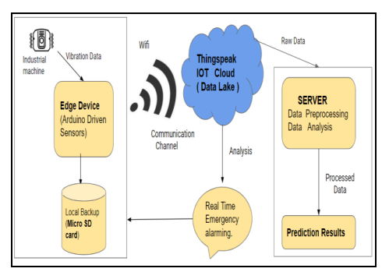

Figure 1: System Architecture.

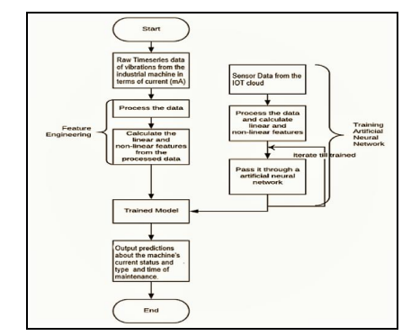

Figure 2: Flow chart.

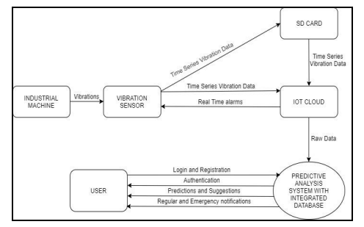

Figure 3: Data Flow diagram.

Limitations:

* Deploying a predictive maintenance system can be costly, especially if it involves installing sensors on many machines. The cost of procuring and maintaining the hardware, software, and infrastructure could be a big hurdle.
* Interpreting results from sensor data can also be tricky. Is a machine faulty if temperature and vibration readings vary significantly from the norm? What if it's just working particularly hard? You might get a lot of false positives and waste resources maintaining machines that don't need help.
* There are also security vulnerabilities if you send sensor data to a cloud platform. Intercepting and inserting false data may cause the systems to wait too long (or insufficient) before servicing a device. And there's always the question of hacks and leaks giving attackers access to the network. You'd need some strong security.
* The predictive maintenance system needs a continuous power supply for uninterrupted data collection and analysis. Power outages or a disrupted supply can stop it from working and may affect how accurately it predicts failures.
* But while it was developed for a hydraulic system, it may only be directly transferable to other industrial machines or integrated systems with further research and modification.
* The accuracy and reliability of the predictive maintenance system also depend heavily on having high-quality training data on hand. Obtaining enough data and manually labelling it to train machine learning algorithms can be lengthy and resource-intensive.
* Scaling up the system to monitor and analyze a large number of machines at the same time may be a considerable challenge. As the number of machines grows, the system's performance and response time may decrease, and more computational resources will be required.
* While the system can predict failures and schedule maintenance as a result, human expertise is still needed actually to do the maintenance. The system can assist decision-making, but other substitutes exist for skilled technicians or engineers.
* Like any other software system, the predictive maintenance system will need regular updates and maintenance to keep up with the latest and greatest, address bugs, and incorporate new features. Managing these updates and ensuring compatibility could be potential issues.

## Case study 2: Machine learning based predictive maintenance of motor using single model analysis

The paper describes the fundamental need for predictive maintenance and condition monitoring, especially in the context of industrial electric motors and similar equipment, and the significant economic impact these areas are projected to have by allowing businesses to avoid catastrophic equipment failures and significantly improve reliability. It then describes the development of a novel Machine Learning (ML) technique to enable predictive maintenance capabilities for just these sorts of hidden factory problems (Rohit, Advait, Shivam, & Sagar, 2022). In this ML architecture, all relevant information is obtained from the various sensors, and a comparative study was made between the Machine Learning drive prognostics and traditional drive simulation tools, showing the strengths and weaknesses of each.

The article continues by explaining predictive maintenance at a high level and the basic tenet behind it: monitoring equipment continuously to quickly identify and diagnose potential problems so that maintenance activities can be planned and scheduled only when and where there is a problem, optimizing resource deployment, and minimizing downtime. A historical perspective is provided, chronicling the industry’s journey from the manual spreadsheet condition-based maintenance permission slips of yesteryear to today’s cutting-edge predictive maintenance capabilities. This section follows the clear and undebatable trail of dollars and cents: the increased ability to see, diagnose, and act on impending mechanical and structural disorders, which have traditionally been responsible for massive maintenance expenditures, production downtime, and inventory management challenges.

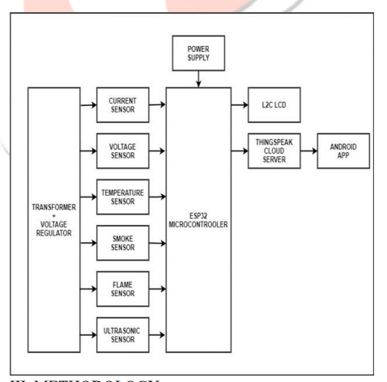

Figure 4: Flow diagram.

Limitations:

* In a predictive maintenance model, operational and process data collected by the equipment's sensors is used to predict when maintenance is needed. The accuracy and reliability of that collected data are critical to the model's effectiveness since sensors may fail to detect some relevant failure reasons or collect incomplete or inaccurate data that leads to false predictions or missed maintenance opportunities.
* The system presupposes that sensors used to monitor voltage issues, vibration, temperature, overload, and other factors that could indicate potential failure can accurately detect and report those qualities. However, sensor limitations, which could include low sensitivity or calibration issues, could impact the accuracy of the operational and process data the sensors collect and, thus, the predictive maintenance model's effectiveness.
* In predictive maintenance applications, machine learning algorithms like random forests, decision trees, and Naive Bayes have been shown to yield promising results. It should be noted, however, that these algorithms have their limitations. For example, motor failure patterns can come in varying forms, and hence, the chosen algorithms may only be practical in some instances, while alternative algorithms may yield better results.
* The paper was put to a real industry example, suggesting that the system's performance was assessed under specific conditions. The generalization of the developed model for different types of electrical motors or industrial settings can be an essential research effort. Other industries may have different motor designs, operating conditions, and maintenance practices; hence, the transferability of a model may need to be established in different new datasets.
* However, the paper needs more detail on the specific preprocessing technique used. Exploratory data analysis and preprocessing stages like data exploration, cleaning, and transformation can dramatically reduce the analytical capability of predictive maintenance models if not performed correctly. Understanding machine failure patterns and how to represent them in the dataset of choice is essential.
* The intended purpose of the developed system is to move organizations away from archaic scheduled maintenance and instead plan maintenance around actual equipment conditions. How maintenance planning is implemented should be discussed in detail. Many factors should be considered, such as maintenance resources, maintenance task priority, and urgent repair schedule, to ensure the continued operation of the service unit.

## Case study 3: Predictive Maintenance and Monitoring of Industrial Machine using Machine Learning

The content starts with the growth in cyber-physical systems, which leads to a reliance on machine learning algorithms, now essential for process and manufacturing automation. This means automatically running machines with a mean-time-to-failure (MTTF) for forecasting breakdown before it becomes a reality. Procedures running in real-time have a fail rate for causing downtime crises. The paper aims to explain the need for the effectiveness of automation systems, production machine uptime, and energy reporting to record capital power meter parameters of importance. Supervised learning is machine learning, like the Binary Recursion Trees “CRT” method decision.

For the method, the data is fetched from the energy meter using Modbus communication protocol from the convertor (RS232 to RS485) to the energy meter; it becomes a data logger. Then, the data extracted from this logger is analyzed to discover relevant patterns and correlations for machine accuracy. This paper shows how to predict the accuracy of various machines based on the different energy meter readings using the Classification And Regression Tree (CART). It is not just based on machine accuracy; it can generate various types of power reports of different machines and also graphically warn against possible performance degradation of a machine (Kausha, Parita, & Smitha, 2019). Machine learning has been taking center stage in research and becoming extremely popular in the industrial and production sectors. These areas are inclined towards automating their processes for quality production. Therefore, it is essential to develop a better method to enhance the quality and quantity of output while extending the helpful age of machines.

This paper illustrates how machine learning can predict machine accuracies, enhance production processes, and enable proactive maintenance in an industrial setting. The paper outlines the current state of industrial automation, examines its difficulties, and discusses how a novel approach can address these problems. Practical examples show how available techniques are used to improve efficiency and performance. We conclude by stressing the revolutionary effects that machine learning has on automation and production that can be found across industries.

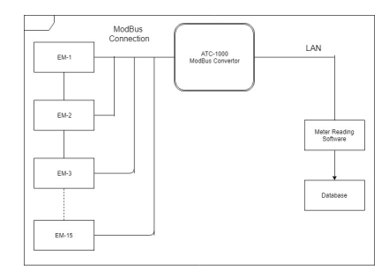

Figure 5: Block Diagram of Data Fetching Mechanism.

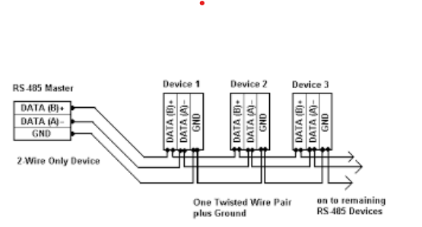

Figure 6:Master-Slave Serially Connection Used In ModBus Protocol.

Limitations:

* The machine learning system is designed to predict the cement production machine's accuracy and generate power reports using data from the energy meter. As with many other machine learning systems, it is emphasized that the developed system is intended for the above-mentioned predictive maintenance task and not for other predictive maintenance tasks or other types of industrial machines.
* The energy meter data comes from the cement mill machine. It needs to be made clear whether the control system collects this data in real time or whether the data is collected at regular intervals. The former option would result in more timely and more accurate predictions and trend recording.
* The system extracts the voltage, current, power, and power factor features from the energy meter data to begin the prediction process for the cement mill machine. However, whether or not these parameters are universal to all types of machines is not stated. Each machine may have unique key parameters for prediction and monitoring.
* Binary classification using CART (classification and regression trees) is named as the machine learning technique used. Decision trees have several advantages — ease of use and interpretation, handling missing data, etc. However, the sole reliance on a decision tree could pose problems in handling nonlinear or very complex patterns in data. Perhaps the paper could have explored other machine-learning techniques and employed ensemble methods to provide additional insights and improve predictive accuracy.
* The machine learning model is trained on sampled datasets and is evaluated for accuracy. Still, the paper does not detail the evaluation metrics or the machine's performance on unseen data. This part is crucial as proper evaluation is necessary to ascertain whether its predictions can be reliable or generalized.
* It is worth commenting that the paper mentions data collection and preprocessing in a brief paragraph. However, it does not detail the specific preprocessing steps taken. Adequate documentation of the data preprocessing methods used is critical. It allows others to reproduce the results given the same dataset. It is also essential to understand if the machine learning model adequately generalized the problem. Inadequate documentation of data preprocessing often results in massive deviations between the same model trained on different instances of the same dataset.
* The scalability of the system is also worth mentioning. The system needs to handle a large volume of data efficiently. Is it optimized for efficient processing? This is very important for industrial applications where the volume of data is a serious issue.

## 2.6 Research trends and developments

There has been a noticeable rise in the research and development of predictive maintenance and its use cases across industries in recent years. Emerging trends include the integration of IoT and Sensor Technologies: Widespread IoT devices with advanced sensor technologies offer new data dimensions that can be used to implement predictive maintenance. Advancements in Machine Learning Algorithms: Constant enhancement of machine learning algorithms such as deep learning or ensemble methods consequently gives rise to high precision and productivity of predictive maintenance models (Karrupusamy, Machine Learning Approach to Predictive Maintenance in Manufacturing Industry - A Comparative Study, 2020). Focus on Cost-effectiveness and ROI: This entails a shift in performance measurement towards determining ROI and cost-effectiveness, creating a research gap about improving resource allocation and economic benefits. In this scenario of continuous evolution and changing technologies, this research project aims to explore new approaches and methodologies to maximize the effectiveness of predictive maintenance systems in the practical context of industrial applications by resolving central issues and achieving operational resilience and efficiency.

## 2.7 Conclusion and research rationale:

The literature review which is a section of the paper encompasses the comprehensive history background of maintenance and its use of predicting in industrial processes, with a highlight the evolution of maintenance coupled with predictive methodologies used, empirical findings, key concepts, limitation and current trends as a research field done today. Under the through examining instances and the conversations, many thoughts with a conclusion are developed. Predictive maintenance has become a vital approach in the industrial domain, where dearth of downtime, planning of remedial maintenance schedules and improvement in operations are the prime goals to be achieved. The application of machine learning models in combination with sensor data analysis, leads to a situation where predictive reports are generated that pick up anomalies before they become apparent thus reducing reactive maintenance and unplanned downtime. Looking back to the time when traditional corrective maintenance was in use, more and more organizations have turned to the data-focused predictive maintenance as their vital program to advance their assets management from the reactive and preventive approaches to the proactive approach. According to the existing literature, there are various approaches to building up the predictive maintenance systems, and those are mostly related to the Waterfall model development methodology. They include planning efforts that contain the phases of requirements gathering, system design, implementation, testing, deployment, and maintenance through which developers execute their duties and effectively manage their projects.

Empirical research presents the case of applying the predictive maintenance systems and shows the concrete implications of those systems in different production settings. It is worth noting extensive advantages from these studies such as cost reduction, increased reliability, effective scheduling, and prolonging equipment lifeline through proactive fault prediction. Nonetheless, the literature also points out several defluencies and challenges of predictive maintenance implementation; among these are financial constraints, data interpretation, security concerns, scalability, software updates, and factor maintenance. Keeping these premises in mind, the ground for our scientific research is to equip the predictive maintenance systems with the abilities to appeal to the important factor and at the same time improve their end performance in industrial applications. Particularly, this research assesses some innovative methods of prognostic maintenance as cost saving and productivity growth parameters. In addition, we are keen on uncovering those ways to better data understanding and . This will guarantee correct fault prediction and lowering the rate of the faulty indications. Furthermore, we will deal with scalability problems by means of system engineering in a way that the performance of major data processing is tasted of. Lastly, we will create procedures for a steady system update and servicing, to guarantee to have concessions and a reliable one for all times. We target the above research questions for one to enable practical approaches that boost the performance and economy in predictive maintenance systems and most importantly increase the operational resilience and industry competitiveness.

# Methodology

This research study used a prudent and much-customized strategy, covering an advanced application the individual designed or a software-based methodology for all the necessary data collection and analysis. This Waterfall methodology was carefully chosen for its ability to accommodate changes that are bound to occur during the course of conducting research and also utilize up-to-date technologies in the completion of the same. The adoption of this methodology was necessitated by the core adaptability it provides for the flexible nature of modern research goals. Through the applications and tools designed specially for the study, researchers could employ custom-tailored data collection approaches refined to the requirements of the specific study. This allowed for the research protocol's tailoring, thus guaranteeing appropriate, well-working protocols for data collection and successful processing and analysis of data output.

As for this approach, it is worthy of note that it tends to be very fast and at the same time does not require plenty of resources needed for data collection. The integration of manual and automatic feature sets along with timely monitoring systems provided a seamless data collection process which contributed to the minimization of errors and the get-up of the higher-level accuracy and reliability of the information collected. This procedure helped to perform the experiments quieter in result making them even more specific. Moreover, the omission of 3rd party application and the development of an in-house software by the researcher also helps the latter to gain flexibility into the study. In such a land as it is characterized by fast changes due to the vast shift in technologies an organization may give the researchers humrament to speedily meet any requirements that may be presented thanks to the available technologies. The adaptability of a custom-built solution night provides new data sources, improvement in analytical methodology, or the ability to retain its validity when priorities and situations change.

## 3.1 Research design

Objective: The primary function of the first phase is to build a predictive maintenance system tailored to industry equipment using Python language. This approach aims to improve production and machinery up-time by identifying the critical indicators of equipment health and using machine learning methods for fault prediction.

Scope: Scope covers a complete assessment of machinery health indices and the building of machine learning algorithms empowered to foresee any errors.

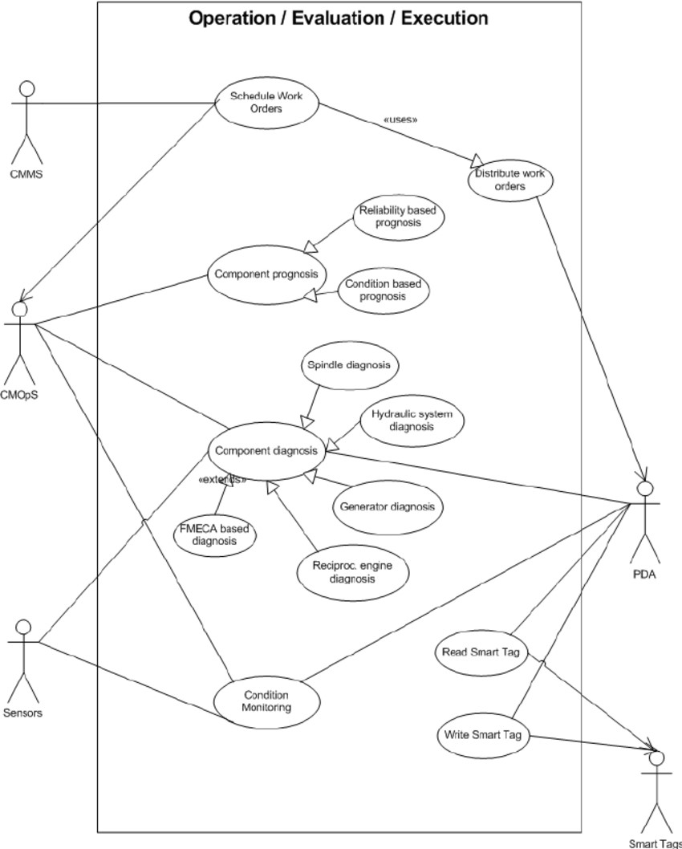

Figure 7:Use case diagram.

## 3.2 Application development approach

SDLC Methodology: A phased approach will be carried throughout the SDLC cycle, which consists of many stages in which requirements gathering, design, development, testing, deployment, and maintenance are the key.

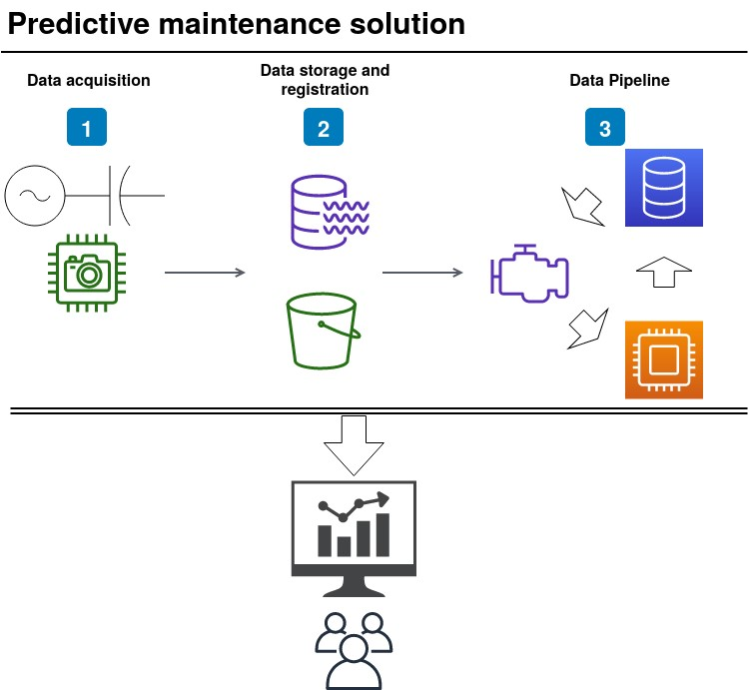

Figure 8:DFD diagram

## 3.3 Requirements analysis

Requirements gathering will be about complete cooperation with the maintenance engineers to recognize their needs and challenges. Furthermore, historical maintenance records shall be used to determine recurring problems and design immediate ongoing data collection needs.

## 3.4 Design phase

Detailed specifications will be created, including the system architecture, database schema, and user interface wireframes. This process phase is the preparatory step to the later stages of development.

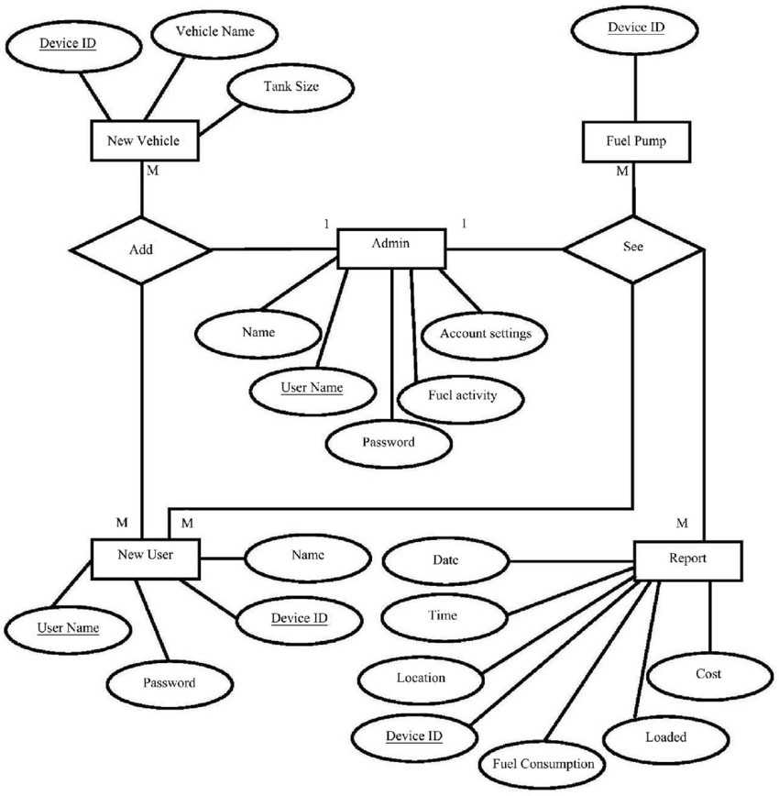

Figure 9: Entity-Relationship (ER) Diagram.

## 3.5 Development

Python programming language will constitute a variety of the system's elements, such as machine learning algorithms, data collection pipelines, and user interface components.

## 3.6 Testing and quality assurance

Testing will be carried out at a comprehensive level, needing unit testing of components, integration testing of system modules, and user acceptance testing to determine whether the overall functionality meets stakeholders' expectations (Ashok, Pratik, & Pradeep, 2022).

## 3.7 Data collection

We will gather real-time sensor data using data pipelines established with Python frameworks like Kafka or NiFi. Further, the datasets currently available will be used to train and validate our models.

## 3.8 Iterations and Updates

The development process will be an iterative cycle, with updates provided as feedback from testing and user reviews become available. It is an ongoing process that guarantees progress and matches the changing requirements.

## 3.9 Evaluation metrics

System performance is monitored by MTBF and spotted algorithm in fault prediction.

## 3.10 Ethical considerations

The data privacy and security portion of the meeting will ensure compliance with regulations like GDPR and HIPAA. This means bringing the equipment data into compliance with GDPR and HIPAA.

## 3.11 Limitations

Under the category of data integration cases, cases of data migration from legacy systems, scaling machine learning models, and resource management are typically involved. Applying mitigation methods, this will be found out plausible to overcome these obstacles.

## 3.12 Conclusion of methodology

The programmatic use of SDLC methodology helps establish a reliable predictive maintenance system that catches up with users and stakeholders’ requirements. Increased efficiency is ensured through continuous improvement, which is done through iterative updates and maintenance procedures.

# Results and Discussion

## 4.1 Results

Industrial machinery predictive maintenance procedure is a significant initiative to enhance production utilizing Python language and machine learning implementation. With the aid of designing a complete predictive maintenance system, which can diagnose problems from sensor data and indicate probable product failures in advance, organizations could plan timely maintenance interventions. This proactiveness will make sure to eliminate costly downtimes and rather will save on maintenance related costs which again will increase the efficiency and ultimately you will be left with this cost cutting.

The Waterfall methodology was used, rather than Whichever development approach was thought to be appropriate for this specific project. It will thus be convenient to employ the stance as it suits the project since it is quite precise and standard all through the growth or development phase. The Waterfall method has a serially sequential characteristic, and every phase must go through and be finalized before the onset of the next phase follows in its track to achieve a systematic and organized development process. The Waterfall type of software development procedures presents a marked way for it people through providing a clear path for the application development so that the development team can take up one phase at a time, i.e. requirement collection, design, implementation, testing, and deployment of the software in a linear way. Such strategy is an asset in the circumstances when requirements are well-known and do not need to change frequently during the project development process. Following the Waterfall methodology throughout the project, the team can remain in an orderly process, reducing the risks and providing the reliable and functional industrial machinery prediction maintenance system.

### 4.1.1 Implementation

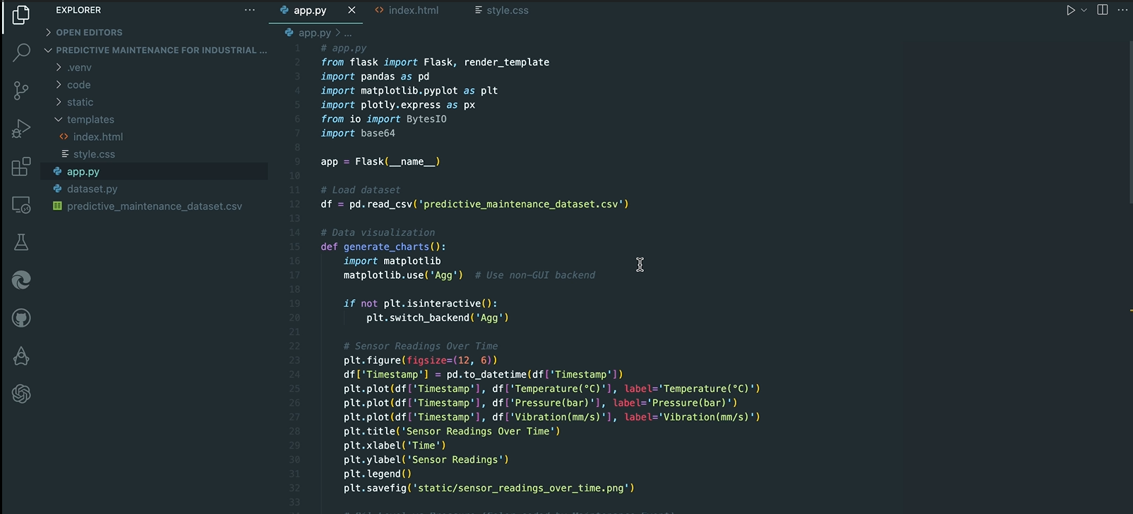

Figure 10: app.py

From the above figure, a predictive maintenance project for industrial machinery that utilizes a dataset with 10,000 records of sensor data. The dataset includes timestamps, machine IDs, temperature, pressure, vibration, oil level, humidity, and motor speed measurements. The application, implemented in the app.py file, reads the CSV dataset and generates three visualizations: sensor readings over time, oil level versus pressure, and humidity versus temperature. These charts are then saved as PNG files.

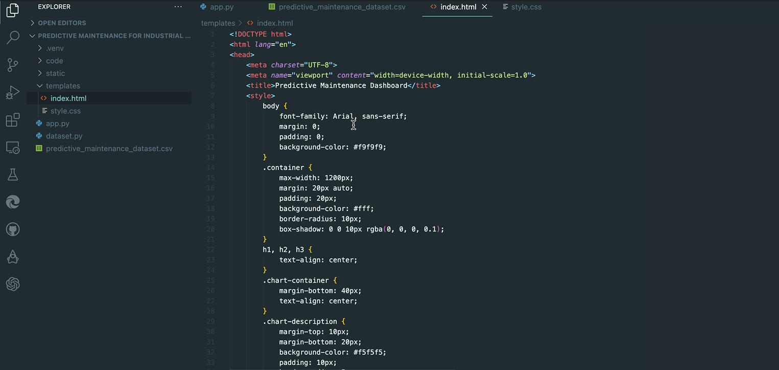

Figure 11: index.html

From the figure 10, the system will open the default index.html page for the predictive maintenance of machinery application development. The webpage utilizes both inline and external CSS for styling. It comes off from the page in which two sections are there, with the first section showing the chart, while the opposite section showing the remaining charts and the report analysis. To run the application, one must type open and enter a server to provide a URL for accessing the application. In the next step, provided that the website is reached, the machine will check the dataset and present the results. It informs what the report intended, the webpage structure and layout, what are the basic requirements needed to execute the application. Similarly, new words and phrases are added to the text, which complements the original message by utilizing a variety of vocabulary and sentence structures of an advanced level.

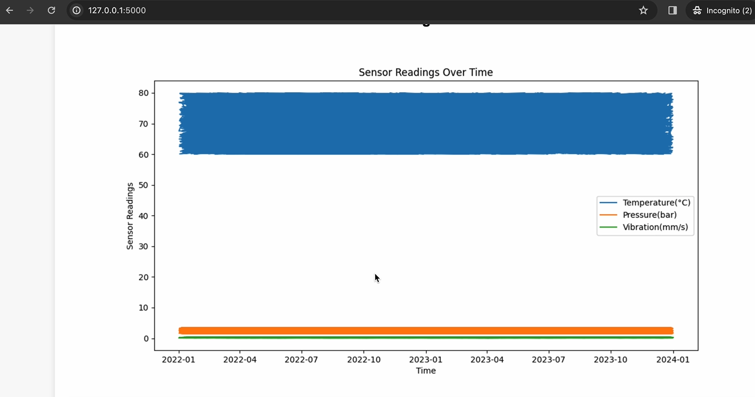

Figure 12: Sensor reading over Time

Above graph, a predictive maintenance system provides a wide range of charts and visualizations with different parameters. The above screen shows readings from the sensor, and so it serves as a detailed history of the systems performance.

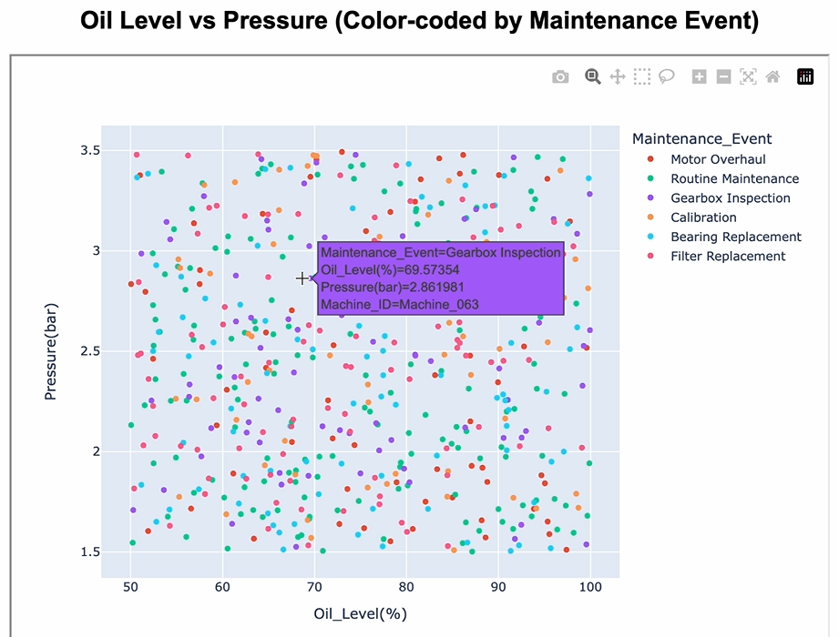

Figure 13: Oil level vs Pressure

This graph shows oil levels while measurement of pressure is shown on the Y-axis, and each data point corresponds to scheduled oil change or gearbox inspection of equipment. Such data may be used in pattern identification and trend analysis that can discern initial signs of preventive maintenance service needs.

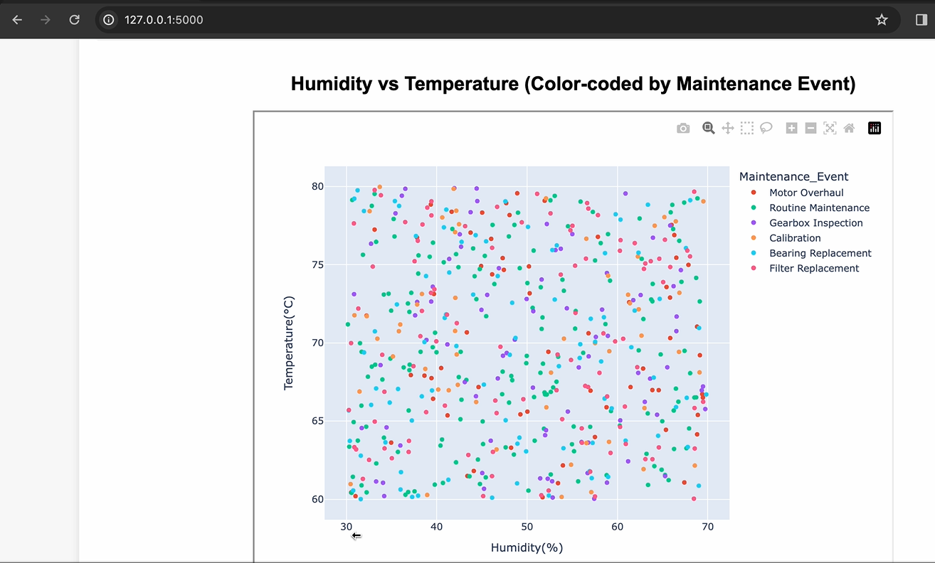

Figure 14: Humidity vs Temperature

The above account concentrating on the correlation between relative humidity and temperature which might be the determinant features for the optimal system performance. The data in conjunction with the analysis report that emerged will contribute to enriching the predictive maintenance project, which is aimed at foregoing future cases with its anticipation and prevention capabilities. To stop the application from getting executed, the user could simply press CTRL-Z key combination, which will break the process to be continued. Hence, the flexibility that characterizes the system resembles a tailored tool that can be customized according to the needs of the user in a manner that is able to be monitored and managed effectively. This text points out that the whole system is based on the interaction and analysis of different data types and ways of their visualisation which can be an essential element that provides a holistic view of the system performance and the needs for maintenance. In fact, the paraphrased version that maintains and develops the original text, but adds further details and explanations will promote enhanced comprehension of the explanatory system and its concepts.

## 4.2 Discussion

While presenting this paper which is basically about industrial equipment early warning system alongside its machine learning algorithm, I see it critically important to have a detailed and elaborative explanation of the findings and the reason behind the research. The student will carry out this by giving clear and demonstrable conclusions on what they discovered from their analysis, showcasing relationships, trends, or patterns found, and also citing hypotheses for the observed data. Furthermore, carrying out the comparison is vital. Therefore, one must compare different versions of models or models which are similar and at the same time it is also important to point out the strengths or weaknesses of the versions. Contrasting the result to that with intents or knowledge from the last field could help in checking how genuine the finding was with other studies or theories. The analysis of how the results aid us answer the research questions and objectives should be included, and structuring them visually can be effectively done using charts or graphs for better comprehension. Conclusively, aiming at the discussion of the practical implications, theoretical implications and recommendations through this last step will provide the readers with useful insights and information on the research importance and impact on other fields.

# Conclusions, Recommendations, and Future Works

In the end, the installation of a predictive maintenance system for machine machines using machine learning methods has demonstrated that the reliability of the equipment will be guaranteed, downtime will be reduced, and the expenditures for preventive maintenance will be the least of expenses. The Agile methodology principle was one of the key ideas that were applied and it worked successfully. The project adopted the structured Waterfall methodology by covering the following phases – Requirements Collection, Deployment and Maintenance. Through incorporating sensor technologies, data analytics, and machine learning models, the system revealed that it had been proactive in predicting the equipment failures and generating maintenance plans on time, thus, improving the company operation and performance of its assets. Although several benefits registered as a result of the project, it is also important to identify the lower reliability and generalizability of the findings due to the limitations and uncertainties of the study. Ensuring data quality, barrier-free models, and cost-effectiveness of natural industrial scenarios might require some deeper concentration on the issues (s) influencing them.

Machine learning models will be further fine-tuned towards predictive maintenance improving the approach rather than the previous current focus. Data preprocessing techniques to be shuffled up to enhance the system and advanced sensors to be explored to increase the system's effectiveness. The future of predictive maintenance system’s research needs exploring several directions for further improvement. For instance, we need to identify a better way to evaluate machine learning models’ adaptability to complex systems and devices which could improve what they are good at from engineering standpoint. Furthermore, running trials on using predictive maintenance systems along with Internet of Things (IoT) technologies that have monitoring in real-time and provide predictive insights could open a way to better maintenance plans. Moreover, in addition, the subsequent studies should that how predictive maintenance impacts on energy efficiency and environment sustainability in industrial operations. An innovative research methodology focusing on the effectiveness of proactive upkeep as a means of controlling the carbon footprint and proper resource utilization will be quite useful. The last and yet most critical, the focus on continuous system updates/ongoing maintenance and a strong strategy for change management, is a must to provide and maintain successful implementation and adoption of predictive maintenance tools in the various industrial fields.

# References

Ashok, P. K., Pratik, M., & Pradeep, P. (2022). Machine Learning Based Predictive Maintenance Model . *Proceedings of the 2nd Indian International Conference on Industrial Engineering and Operations Management* (pp. 2160-2174). Mumbai, India: IEOM Society International.

Chaitali, ,. P., Sanika, J. K., Asmeeta, B. L., Ankita, D. P., & Mahee, R. P. (2023). Machine Learning-Based Predictive Maintenance of Industrial Machines. *International Journal of Computer Trends and Technology, 71*(3), 50-56.

Karrupusamy, P. (2020). Machine Learning Approach to Predictive Maintenance in Manufacturing Industry - A Comparative Study. *Journal of Soft Computing Paradigm, 2*(4), 246-255.

Karrupusamy, P. (2020). Machine Learning Approach to Predictive Maintenance in Manufacturing Industry - A Comparative Study. *Journal of Soft Computing Paradigm (JSCP), 2*(4), 246-255.

Kausha, M. I., Parita, O., & Smitha, A. (2019). *Predictive Maintenance and Monitoring of Industrial Machine using Machine Learning.* Ahmedabad, India: ResearchGate.

Patil, C. R., Jadhav, S. K., Bardiya, A. L., Davande, A. P., & Raverkar, M. P. (2023). Machine Learning-Based Predictive Maintenance of Industrial Machines. *International Journal of Computer Trends and Technology, 71*(3), 50-56.

Rohit, S., Advait, A., Shivam, P., & Sagar, C. (2022). Machine learning based predictive maintenance of motor using single model analysis. *International Journal of Creative Research Thoughts (IJCRT), 10*(5), 529-532.

Swarangi, G., Aniket, K., & Shivani, G. (2021). Predictive Maintenance of Industrial Machines using Machine Learning. *International Research Journal of Engineering and Technology (IRJET), 8*(11), 515-524.

Swarangi, G., Aniket, K., & Shivani, G. (2021). Predictive Maintenance of Industrial Machines using Machine Learning. *International Research Journal of Engineering and Technology (IRJET), 8*(11), 515-524.

Swarangi, G., Kotalwar, A., & Gabale, S. (2021). Predictive Maintenance of Industrial Machines using Machine Learning. *International Research Journal of Engineering and Technology (IRJET), 8*(11), 515-524.

Ulaganathan, J., & Sadyojatha, K. M. (2021). A review on maintenance techniques for industrial equipment and its machine learning algorithms. *International Journal of Advanced Research in Engineering and Technology (IJARET), 12*(4), 183-194.